Cointegration and ECM: AUDUSD and USDCHF
Method 27 / Engle-Granger on log closes / one-lag ECM / Alpari D1 full available history

Study setup
Logical pair: PX=AUDUSD , PY=USDCHF
Broker symbols: AUDUSD_i , USDCHF_i
Snapshot: 2026-11-03_majors_alpari_D1
Timeframe: D1
Matched window: 1999-01-05 to 2026-11-02 (UTC bar dates)
Matched level count n: 7200
Dropped unfinished last bar dated 2026-11-03 UTC after a tick-volume check against the prior complete day.
ECM lags of deltas: 1
Complete matched rows (Excel): AUDUSD-USDCHF_Coint_D1.xlsx
Complete matched rows (HTML table): AUDUSD-USDCHF_Coint_D1_data.html

Method carried forward
Engle-Granger cointegration works on log price levels, not returns. For each unordered pair, PX is the left leg and PY the right leg. Step one: OLS ln(PY) = alpha + beta * ln(PX) + e. Step two: statsmodels Engle-Granger coint test on (ln(PY), ln(PX)). Error-correction: delta ln(PY)_t = c + kappa * e_{t-1} + lagged delta ln(PY) and delta ln(PX) (one lag each) + u_t. Headline is the Engle-Granger p-value (lower = stronger evidence of a stationary spread) with kappa and beta reported alongside. Same-sample Pearson r of log returns is a side check only. beta is not an automatic lot-size hedge. This is not a trading signal.

Results (headline)
alpha: -0.120401
beta: -0.633698
Engle-Granger t: -0.944050
Engle-Granger p: 0.912955
5% critical value: -3.336979
ECM kappa: -0.000408
kappa t-stat: -0.9374
ECM R^2: 0.002227
spread std: 0.178555
Pearson r (returns): -0.380878

Conclusion
Engle-Granger for PY=USDCHF on PX=AUDUSD: beta=-0.6337, alpha=-0.1204, coint_t=-0.9440, p=0.9130 (5% crit=-3.3370). ECM kappa=-0.0004 (t=-0.94). Pearson r of returns = -0.3809. beta is not a lot-size hedge. Not a trading signal.

Charts
Daily closes

Engle-Granger residual spread
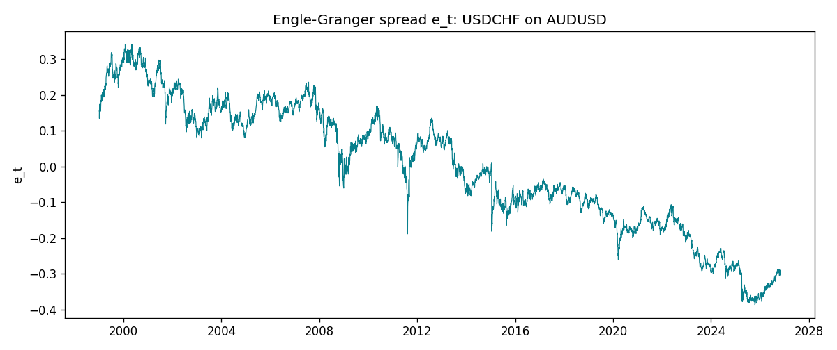
Daily log returns
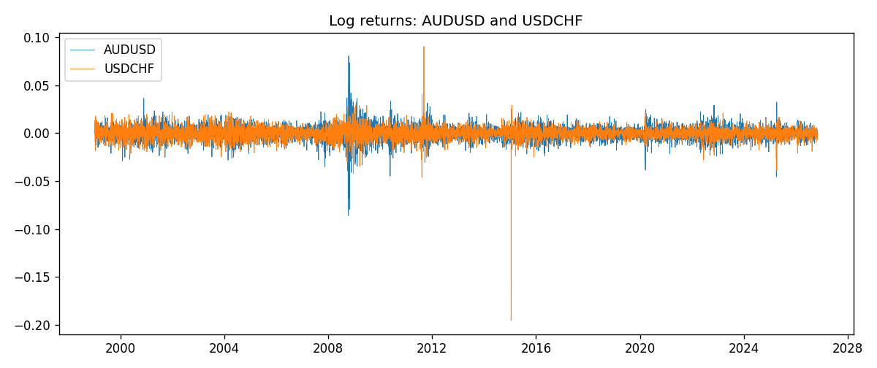

Data report
Matched rows are in the sibling Excel workbook named AUDUSD-USDCHF_Coint_D1.xlsx. Embedding all rows as a Word table is impractical; this file holds column summaries and the first and last 15 matched rows.
Column summaries
column | count | mean | std | min | 25% | 50% | 75% | max
AUDUSD_open | 7200 | 0.7519587 | 0.13528421 | 0.4785 | 0.6610975 | 0.731415 | 0.8091275 | 1.10284
USDCHF_open | 7200 | 1.0982244 | 0.25258622 | 0.72022 | 0.920675 | 0.990175 | 1.238625 | 1.8219
AUDUSD_high | 7200 | 0.75601148 | 0.13584385 | 0.4878 | 0.6647 | 0.734785 | 0.8152525 | 1.10795
USDCHF_high | 7200 | 1.1035234 | 0.25433538 | 0.73305 | 0.9249475 | 0.99377 | 1.2436 | 1.8313
AUDUSD_low | 7200 | 0.74790307 | 0.1345988 | 0.4775 | 0.65778 | 0.727495 | 0.804225 | 1.0975
USDCHF_low | 7200 | 1.0930985 | 0.25099871 | 0.08565 | 0.917415 | 0.98668 | 1.232725 | 1.8121
AUDUSD_close | 7200 | 0.75201172 | 0.13526687 | 0.4786 | 0.6612 | 0.731695 | 0.8091975 | 1.10169
USDCHF_close | 7200 | 1.0982149 | 0.25248642 | 0.72025 | 0.92097 | 0.990145 | 1.238625 | 1.8217
AUDUSD_tick_volume | 7200 | 77358.386 | 138142.18 | 109 | 5440 | 43334.5 | 71332.25 | 1234623
USDCHF_tick_volume | 7200 | 74199.562 | 113414.45 | 350 | 12776 | 40195 | 70261.25 | 858589
AUDUSD_spread | 7200 | 30.817222 | 16.887144 | 0 | 13 | 30 | 50 | 50
USDCHF_spread | 7200 | 26.104306 | 24.710129 | 0 | 5 | 16 | 50 | 100
AUDUSD_real_volume | 7200 | 5.2428187e+09 | 1.2538918e+11 | 0 | 0 | 0 | 0 | 3.811512e+12
USDCHF_real_volume | 7200 | 2.3239785e+10 | 8.9047261e+10 | 0 | 0 | 0 | 0 | 1.9331921e+12
AUDUSD_log_price | 7200 | -0.30076227 | 0.17691612 | -0.7368901 | -0.41369891 | -0.31239152 | -0.21171227 | 0.09684536
USDCHF_log_price | 7200 | 0.07019162 | 0.21083378 | -0.32815691 | -0.08232782 | -0.00990388 | 0.21400189 | 0.59977013
AUDUSD_log_return | 7200 | 2.837e-05 | 0.00754598 | -0.08602525 | -0.00385535 | 0.0002835 | 0.00415437 | 0.0806166
USDCHF_log_return | 7200 | -7.168e-05 | 0.00659376 | -0.19545699 | -0.00336083 | 8.057e-05 | 0.00331954 | 0.09051364
spread_e | 7200 | 0 | 0.17855514 | -0.3864038 | -0.13092159 | 0.00660646 | 0.14905377 | 0.34200012
ecm_fitted | 7199 | -7.223e-05 | 0.00031121 | -0.00439536 | -0.00022997 | -6.619e-05 | 8.754e-05 | 0.00944249
First 15 matched rows (selected columns)
time | AUDUSD_log_price | USDCHF_log_price | spread_e | AUDUSD_log_return | USDCHF_log_return
1999-01-05 | -0.47561937 | 0.31656103 | 0.13556291 | -0.00080418179 | 0.0039424743
1999-01-06 | -0.46378302 | 0.33016668 | 0.15666922 | 0.011836351 | 0.013605652
1999-01-07 | -0.45491799 | 0.3207783 | 0.15289858 | 0.0088650256 | -0.0093883841
1999-01-08 | -0.45460283 | 0.33181857 | 0.16413857 | 0.00031515916 | 0.011040268
1999-01-11 | -0.44738145 | 0.33711489 | 0.17401106 | 0.0072213815 | 0.0052963193
1999-01-12 | -0.4522423 | 0.32728733 | 0.16110319 | -0.0048608485 | -0.0098275602
1999-01-13 | -0.46013251 | 0.30902763 | 0.13784348 | -0.0078902098 | -0.018259701
1999-01-14 | -0.46282943 | 0.30660196 | 0.13370879 | -0.002696916 | -0.0024256692
1999-01-15 | -0.45570632 | 0.32454424 | 0.15616496 | 0.007123101 | 0.01794228
1999-01-18 | -0.4547604 | 0.3213586 | 0.15357875 | 0.00094592471 | -0.0031856384
1999-01-19 | -0.44753788 | 0.32128608 | 0.15808312 | 0.0072225153 | -7.2518946e-05
1999-01-20 | -0.4462871 | 0.32851207 | 0.16610172 | 0.0012507819 | 0.0072259871
1999-01-21 | -0.44550616 | 0.3246888 | 0.16277334 | 0.00078094498 | -0.0038232689
1999-01-22 | -0.4577589 | 0.32454424 | 0.15486424 | -0.012252745 | -0.0001445609
1999-01-25 | -0.46171805 | 0.32699893 | 0.15481004 | -0.0039591468 | 0.0024546976
Last 15 matched rows (selected columns)
time | AUDUSD_log_price | USDCHF_log_price | spread_e | AUDUSD_log_return | USDCHF_log_return
2026-10-13 | -0.35923536 | -0.18339413 | -0.29064 | 0.0035007712 | -0.0024955621
2026-10-14 | -0.36075468 | -0.1804553 | -0.28866396 | -0.0015193215 | 0.0029388325
2026-10-15 | -0.36829939 | -0.19024083 | -0.30323056 | -0.0075447063 | -0.0097855323
2026-10-16 | -0.36490875 | -0.19386391 | -0.304705 | 0.0033906408 | -0.0036230826
2026-10-19 | -0.35982275 | -0.19022874 | -0.29784684 | 0.0050859986 | 0.0036351779
2026-10-20 | -0.35636071 | -0.19285686 | -0.29828107 | 0.0034620426 | -0.0026281224
2026-10-21 | -0.35275407 | -0.19325713 | -0.29639583 | 0.0036066384 | -0.00040027413
2026-10-22 | -0.35402133 | -0.19806077 | -0.30200252 | -0.0012672558 | -0.0048036381
2026-10-23 | -0.35164476 | -0.19240826 | -0.29484398 | 0.0023765656 | 0.005652514
2026-10-26 | -0.35484804 | -0.19056746 | -0.2950331 | -0.0032032829 | 0.0018407959
2026-10-27 | -0.35318105 | -0.18795741 | -0.29136668 | 0.0016669876 | 0.0026100526
2026-10-28 | -0.3490895 | -0.18897162 | -0.28978808 | 0.0040915541 | -0.0010142111
2026-10-29 | -0.35318105 | -0.19383964 | -0.29724891 | -0.0040915541 | -0.0048680164
2026-10-30 | -0.35217082 | -0.19312369 | -0.29589278 | 0.0010102376 | 0.00071594559
2026-11-02 | -0.35708932 | -0.20026966 | -0.30615559 | -0.0049184984 | -0.0071459744

